DAX ANSWER SHEET
Kenya Agricultural Performance — Power BI Project
Name: Feddy Mwanjumwa
Project: Kenya Agricultural Performance Dashboard
Tool: Microsoft Power BI

1. Math & Statistical Functions
Question 1: Calculate Total Revenue
Total Revenue =SUM('Kenya Crop Dataset'[Revenue (KES)])
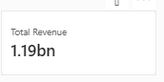

Question 2: Calculate Total Cost
Total Cost =
SUM('Kenya Crop Dataset'[Cost of Production (KES)])

Question 3: Calculate Total Profit
Total Profit =
SUM('Kenya Crop Dataset'[Profit (KES)])
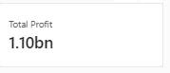

Question 4: Calculate Total Yield
Total Yield =
SUM('Kenya Crop Dataset'[Yield (Kg)])
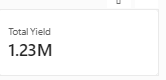

Question 5: Calculate Total Calculated Profit using SUMX
Total Calculated Profit =
SUMX( 'Kenya Crop Dataset', ('Kenya Crop Dataset'[Yield (Kg)] * ‘ Kenya Crop Dataset'[Market
Price (KES/Kg)]) - 'Kenya Crop Dataset'[Cost of Production (KES)])
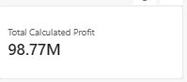

Question 6: Calculate Average Market Price
Average Market Price =
AVERAGE('Kenya Crop Dataset'[Market Price (KES/Kg)])
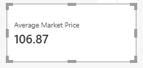

Question 7: Calculate Average Profit
Average Profit per Crop =
AVERAGEX('Kenya Crop Dataset', ('Kenya Crop Dataset'[Yield (Kg)] * 'Kenya Crop Dataset'[Market Price (KES/Kg)])- 'Kenya Crop Dataset'[Cost of Production (KES)])
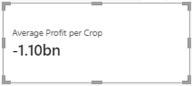

Question 8: Calculate Median Yield
Median Yield =
MEDIAN('Kenya Crop Dataset'[Yield (Kg)])
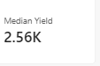

2. Filter Context
Question 9: Calculate Revenue Above KES 5,000
Revenue Above 5000 =
CALCULATE [Total Revenue]FILTER('Kenya Crop Dataset','Kenya Crop Dataset'[Revenue (KES)] > 500))
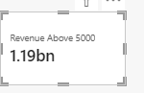

Question 10: Calculate Revenue for the Western Region
West Revenue =
CALCULATE([Total Revenue],'Kenya Crop Dataset'[Region] = "West)
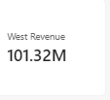

Question 11: Check Whether One Crop is Selected
One Crop Selected =
IF(HASONEVALUE('Kenya Crop Dataset'[Crop Type])"One Crop Selected","Multiple Crops Selected")
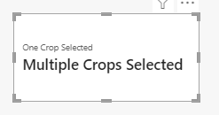

Question 12: Calculate Overall Revenue Using ALL
Overall Revenue =
CALCULATE([Total Revenue],ALL('Kenya Crop Dataset')
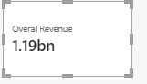

Question 13: Calculate Revenue by Region Using ALLEXCEPT
Revenue by Region = calculate([Total Revenue],ALLEXCEPT('Kenya_Crops_Dataset',Kenya_Crops_Dataset[Region]))
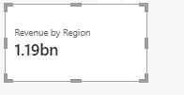

Question 14: Remove the Region Filter
Revenue Without Region Filter = calculate([Total Revenue],REMOVEFILTERS((Kenya_Crops_Dataset[Region])))
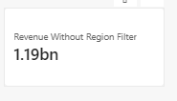

3. Logical Functions
Question 15: Calculate Profit Margin
Profit Margin = Divide([Total Profit],[Total Revenue],0)
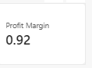

Question 16: Classify Profit Margin as High or Low
Profit Margin level = IF([Profit Margin] > 0.2,"High","Low")

Question 17: Check for High Revenue AND High Profit Margin
High Revenue & High Margin = if(and([Total Revenue] > 5000,[Profit Margin]> 0.2),"Yes","No")
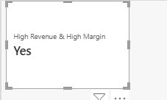

Question 18: Check for High Revenue OR High Profit Margin
High Revenue & High Margin = if(or([Total Revenue] > 5000,[Profit Margin]> 0.2),"Yes","No")

Question 19: Classify Revenue as High, Medium or Low
Revenue Level column = IF([Total Revenue] > 10000, "High", IF([Total Revenue] >= 5000, "Medium","Low"))
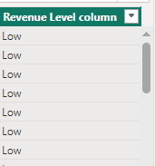

Question 20: Create Region Labels
Region Label = switch('Kenya_Crops_Dataset'[Region],"West","Western Region","East","Eastern Region","Central", "Central Region","Unknown Region")

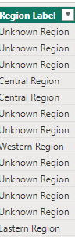

Question 21: Calculate Revenue per Kilogram Using IFERROR
Revenue per Kg = IFERROR([Total Revenue]/[Total Yield],0)

4. Text Functions
Question 22: Check if Crop Type is Exactly "Potatoes"
Is Potatoes = EXACT('Kenya_Crops_Dataset'[Crop Type],"Potatoes")
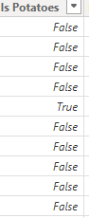

Question 23: Check if Farmer Name is Exactly "Mary Wanjiku"
Is Mary Wanjiku = exact('Kenya_Crops_Dataset'[Farmer Name],"Mary Wanjiku")
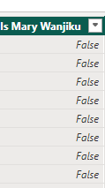

Question 24: Find "Farmer" in Farmer Name
Find John = find("John",'Kenya_Crops_Dataset'[Farmer Name],1,0)
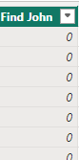

Question 25: Find "Pot" in Crop Type
Find Pot = Find ("Pot",'Kenya_Crops_Dataset'[Crop Type],1,0)
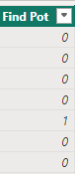

Question 26: Format Revenue
Formatted Revenue = format([Total Revenue],"KES#,##0.00")

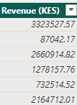

Question 27: Format Planting Date
Formatted Planting Date = FORMAT(MAX('Kenya_Crops_Dataset'[Planting Date]), "MMMM D, YYYY")
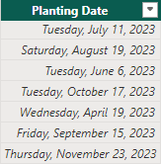

Question 28: Format Yield
Formatted Yield = format([Total Yield],"0.00")
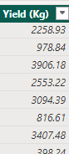

Question 29: Extract First 3 Characters of Crop Type
Crop First 3 = left('Kenya_Crops_Dataset'[Crop Type],3)
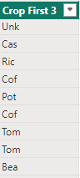

Question 30: Extract First 4 Characters of County
County First 4 = left('Kenya_Crops_Dataset'[County],4)
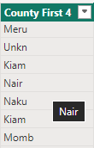

Question 31: Extract First 5 Characters of Farmer Name
Farmer First 5 = left('Kenya_Crops_Dataset'[Farmer Name],5)
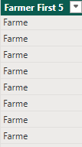

Question 32: Extract Last 5 Characters of Farmer Name
Farmer Last 5 = right('Kenya_Crops_Dataset'[Farmer Name],5)
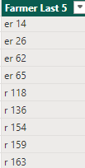

Question 33: Extract Last 3 Characters of Crop Type
Crop Last 3 = right('Kenya_Crops_Dataset'[Crop Type],3)
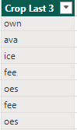

Question 34: Extract Last 4 Characters of County
County last 4 = right('Kenya_Crops_Dataset'[County],4)
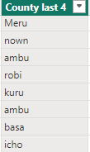

Question 35: Count Characters in Farmer Name
Farmer Name Length = LEN('Kenya_Crops_Dataset'[Farmer Name])
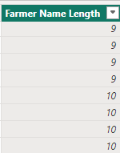

Question 36: Count Characters in Crop Type
Crop Length = len('Kenya_Crops_Dataset'[Crop Type])
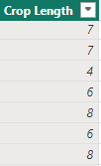

Question 37: Count Characters in County
County Length = len('Kenya_Crops_Dataset'[County])
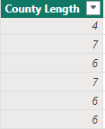

Question 38: Convert Crop Type to Lowercase
Crop Lower = LOWER('Kenya_Crops_Dataset'[Crop Type])
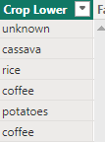

Question 39: Convert Farmer Name to Uppercase
Farmer Upper = upper('Kenya_Crops_Dataset'[Farmer Name])
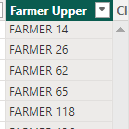

Question 40: Remove Extra Spaces from Crop Type
Clean Crop Type = trim('Kenya_Crops_Dataset'[Crop Type])
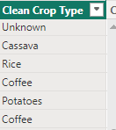

Question 41: Remove Extra Spaces from Farmer Name
Clean Farmer Name = Trim('Kenya_Crops_Dataset'[Farmer Name])
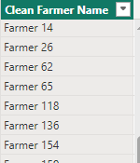

Question 42: Combine Farmer Name and Crop Type
Farmer Crop = CONCATENATE('Kenya_Crops_Dataset'[Farmer Name],"-" & 'Kenya_Crops_Dataset'[Crop Type])
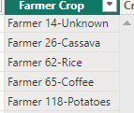

Question 43: Create Crop Prefix and County
Crop Prefix County = left('Kenya_Crops_Dataset'[Crop Type],3) & "-" & 'Kenya_Crops_Dataset'[County]
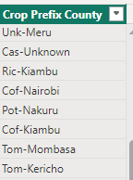

Question 44: Combine Farmer Name and Planting Date
Farmer Planting Date = 'Kenya_Crops_Dataset'[Farmer Name] & "-" & format(Kenya_Crops_Dataset[Planting Date],"mmmm d, yyyy")
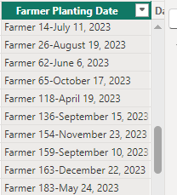

5. Date & Time Intelligence
Question 45: Calculate Days Since Planting
Days Since Planting = datediff('Kenya_Crops_Dataset'[Planting Date],today(), day)
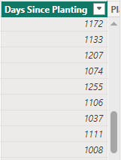

Question 46: Extract Planting Month
Planting Month = Month('Kenya_Crops_Dataset'[Planting Date])
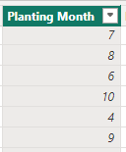

Question 47: Extract Planting Year
Planting Year = YEAR('Kenya_Crops_Dataset'[Planting Date])
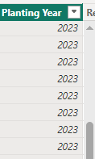

Question 48: Calculate Year-to-Date Revenue
YTD Revenue = TOTALYTD([Total Revenue],DateTable[Date])

Question 49: Calculate Revenue for the Same Period Last Year
Revenue Last Year = calculate([Total Revenue],SAMEPERIODLASTYEAR(DateTable[Date]))
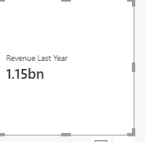

Question 50: Calculate Revenue Three Months Ago
Revenue 3 Months Ago = CALCULATE([Total Revenue],DATEADD(DateTable[Date],-3,month))
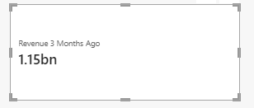

Question 51: Calculate Revenue Between July and September 2023
Revenue Jul-Sep 2023 =
CALCULATE(
[Total Revenue],
DATESBETWEEN(
DateTable[Date],
DATE(2023, 7, 1),
DATE(2023, 9, 30)
)
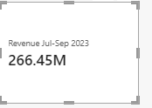

6. Dashboard Measures
Question 52: Calculate Total Number of Farmers
Total Farmers =
DISTINCTCOUNT(Kenya_Crops_Dataset[Farmer Name])
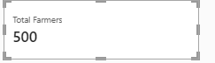

Question 53: Calculate Profit per Acre
Profit per Acre = divide([Total Profit],sum('Kenya_Crops_Dataset'[Planted Area (Acres)]),0)
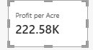

7. Date Table
The Date Table used for the time-intelligence calculations was:
DateTable =
CALENDAR(
DATE(2023, 1, 1),
DATE(2024, 12, 31)
)
Year
Year =
YEAR([Date])
Month Number
Month Number =
MONTH([Date])
Month
Month =
FORMAT([Date], "MMMM")
Quarter
Quarter =
"Q" & FORMAT([Date], "Q")
Date Table relationship:
DateTable[Date] → Kenya Crop Dataset[Planting Date]
Relationship: One-to-many, active relationship.
Date Table: Marked as the official Date Table in Poer Bi.

